# Q1) Write WordCount program using Hadoop CODE: pom.xml <dependency>

<groupId>org.apache.hadoop</groupId>

<artifactId>hadoop-common</artifactId>

<version>3.3.3</version>

</dependency>

<dependency>

<groupId>org.apache.hadoop</groupId>

<artifactId>hadoop-mapreduce-client-core</artifactId>

<version>3.3.3</version>

</dependency>

# WC_Mapper.java

import java.io.IOException; import java.util.StringTokenizer; import org.apache.hadoop.io.IntWritable; import org.apache.hadoop.io.LongWritable; import org.apache.hadoop.io.Text; import org.apache.hadoop.mapred.MapReduceBase; import org.apache.hadoop.mapred.Mapper; import org.apache.hadoop.mapred.OutputCollector; import org.apache.hadoop.mapred.Reporter;

public class WC_Mapper extends MapReduceBase implements Mapper<LongWritable,Text,Text,IntWritable>{ private final static IntWritable one = new IntWritable(1); private Text word = new Text();

public void map(LongWritable key, Text value,OutputCollector<Text,IntWritable> output,

Reporter reporter) throws IOException{

String line = value.toString();

StringTokenizer tokenizer = new StringTokenizer(line); while (tokenizer.hasMoreTokens()){ word.set(tokenizer.nextToken());

output.collect(word, one);

}

}

}

# WC_Reducer

import java.io.IOException; import java.util.Iterator; import org.apache.hadoop.io.IntWritable; import org.apache.hadoop.io.Text; import org.apache.hadoop.mapred.MapReduceBase; import org.apache.hadoop.mapred.OutputCollector; import org.apache.hadoop.mapred.Reducer;

import org.apache.hadoop.mapred.Reporter;

public class WC_Reducer extends MapReduceBase implements Reducer<Text,IntWritable,Text,IntWritable> {

public void reduce(Text key, Iterator<IntWritable> values,OutputCollector<Text,IntWritable> output,

Reporter reporter) throws IOException { int sum=0; while (values.hasNext()) {

sum+=values.next().get();

}

output.collect(key,new IntWritable(sum));

}

}

# WC_Runner

import java.io.IOException; import org.apache.hadoop.fs.Path; import org.apache.hadoop.io.IntWritable; import org.apache.hadoop.io.Text; import org.apache.hadoop.mapred.FileInputFormat; import org.apache.hadoop.mapred.FileOutputFormat; import org.apache.hadoop.mapred.JobClient; import org.apache.hadoop.mapred.JobConf; import org.apache.hadoop.mapred.TextInputFormat; import org.apache.hadoop.mapred.TextOutputFormat; public class WC_Runner {

public static void main(String[] args) throws IOException{ JobConf conf = new JobConf(WC_Runner.class); conf.setJobName("WordCount"); conf.setOutputKeyClass(Text.class); conf.setOutputValueClass(IntWritable.class); conf.setMapperClass(WC_Mapper.class); conf.setCombinerClass(WC_Reducer.class); conf.setReducerClass(WC_Reducer.class); conf.setInputFormat(TextInputFormat.class); conf.setOutputFormat(TextOutputFormat.class); FileInputFormat.setInputPaths(conf,new Path(args[0]));

FileOutputFormat.setOutputPath(conf,new Path(args[1]));

JobClient.runJob(conf);

}

}

# Input file

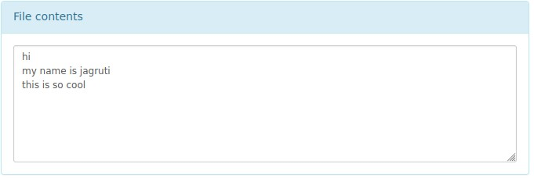

# Output file

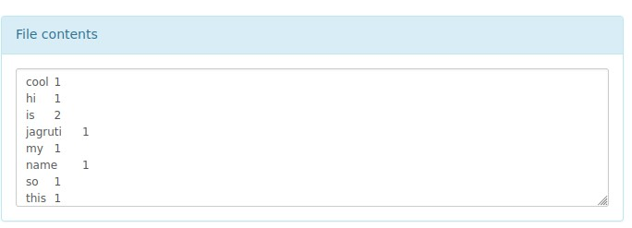

# Q2)Using Power Pivot (Excel) Perform the following on any dataset

**a)** **Big Data Analysis b) Big Data Charting Dataset :**

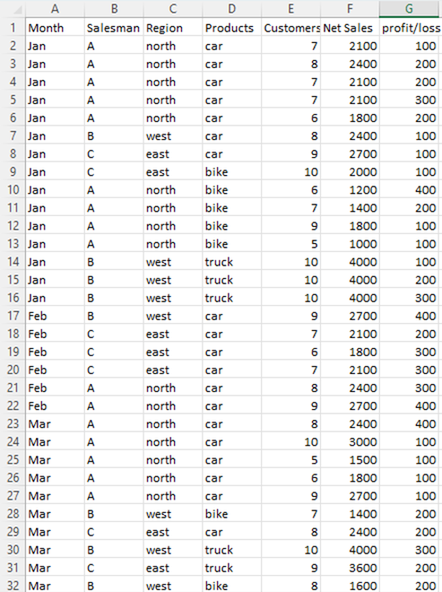

**Sales by region and product :**

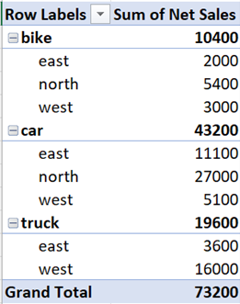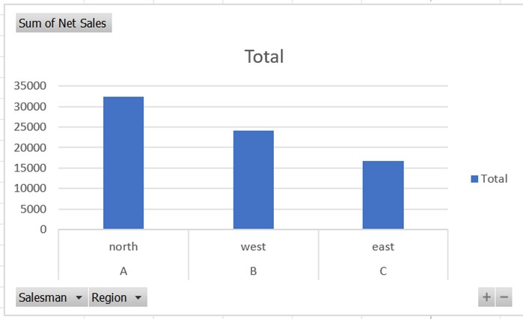

**Customer count by salesperson :**

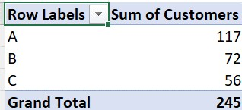

# Q3) Buyer event analytics using Cassandra on suitable product sales data

create keyspace buyer_events with replication = {'class' :

'SimpleStrategy','replication_factor':'1'}; use buyer_events; BUYERS TABLE :

create table buyers(

... buyer_id int primary key,

... username text,

... email text,

... address text);

Inserting :

insert into buyers(buyer_id,username,email,address)

... values(1,'user1','user1@example.com','hyd'); cqlsh:buyer_events> insert into buyers(buyer_id,username,email,address)

... values(2,'user2','user2@example.com','mum'); cqlsh:buyer_events> insert into buyers(buyer_id,username,email,address)

... values(3,'user3','user3@example.com','pun'); cqlsh:buyer_events> insert into buyers(buyer_id,username,email,address)

... values(4,'user4','user4@example.com','hyd'); cqlsh:buyer_events> insert into buyers(buyer_id,username,email,address)

... values(5,'user5','user5@example.com','pun'); insert into buyers(buyer_id,username,email,address)

... values(6,'user6','user6@example.com','mum');

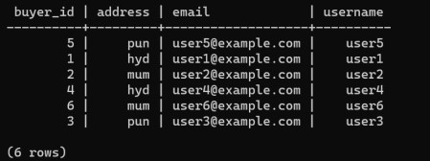

PRODUCTS TABLE :

create table products(

... product_id int primary key,

... name text,

... category text,

... price int);

cqlsh:buyer_events> insert into products(product_id,name,category,price)

... values (1, 'coffee maker', 'appliances', 60); cqlsh:buyer_events> insert into products (product_id, name, category, price)

... values (2, 'phone', 'electronics', 300); cqlsh:buyer_events> insert into products (product_id, name, category, price)

... values (3, 'led tv', 'electronics', 600); cqlsh:buyer_events> insert into products (product_id, name, category, price)

... values (4,'running shoes', 'apparel', 100);

cqlsh:buyer_events> insert into products (product_id, name, category, price)

... values (5,'oven', 'appliances', 500); cqlsh:buyer_events> select * from products;

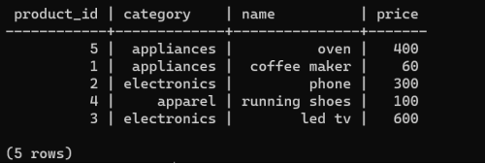

PURCHASE HISTORY TABLE :

create table purchase_history(

... transactionID int primary key,

... buyer_id int,

... product_id int,

... quantity int,

... total_amount int,

... purchase_date timestamp);

INSERTIONS :

insert into

purchase_history(transactionID,buyer_id,product_id,quantity,total_amount,purchase_date) ... values(1,1,5,2,800,toTimestamp(now()));

cqlsh:buyer_events> insert into purchase_history(transactionID,buyer_id,product_id,quantity,total_amount,purchase_date)

... values(2,1,4,4,400,toTimestamp(now()));

cqlsh:buyer_events> insert into purchase_history(transactionID,buyer_id,product_id,quantity,total_amount,purchase_date)

... values(3,2,4,1,100,toTimestamp(now()));

cqlsh:buyer_events> insert into purchase_history(transactionID,buyer_id,product_id,quantity,total_amount,purchase_date)

... values(4,2,1,3,180,toTimestamp(now()));

cqlsh:buyer_events> insert into purchase_history(transactionID,buyer_id,product_id,quantity,total_amount,purchase_date)

... values(5,3,3,4,2400,toTimestamp(now()));

cqlsh:buyer_events> insert into purchase_history(transactionID,buyer_id,product_id,quantity,total_amount,purchase_date) ... values(6,4,2,2,600,toTimestamp(now()));

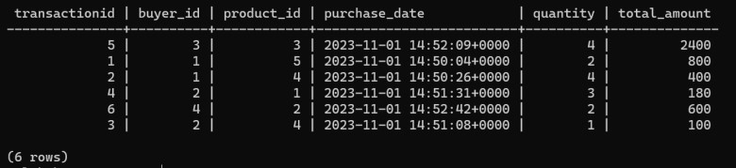

QUERIES :

1. RETRIEVE BUYER’S PURCHASE HISTORY

select * from purchase_history where buyer_id = 1 allow filtering;

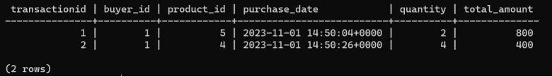

1. FIND TOTAL NUMBER OF PRODUCTS

select count(product_id) from products;

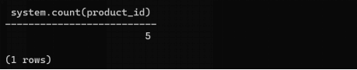

1. RETRIEVE TOTAL SPENDING BY A BUYER

select sum(total_amount) from purchase_history where buyer_id = 2 allow filtering;

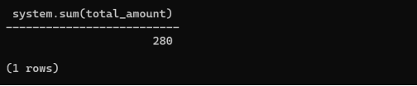

1. RETRIEVE PRODUCTS BY CATEGORY

select * from products where category = 'electronics' allow filtering;

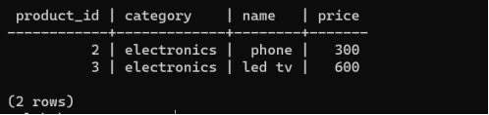

1. FIND THE MAXIMUM PRICE

Select max(price) from products;

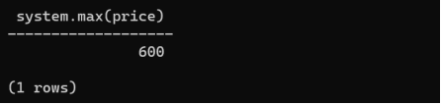

1. TO FIND TOTAL NUMBER OF BUYERS

select count(buyer_id) from buyers;

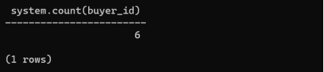

1. FIND AVERAGE PRICE OF PRODUCTS OF A PARTICULAR CATEGORY

select avg(price) from products where category='electronics' allow filtering;

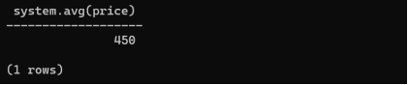

1. SELECT PRODUCTS IN A PARTICULAR PRICE RANGE

select * from products where price>=100 and price<=400 allow filtering;

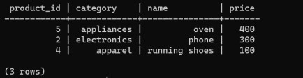

1. TO FIND NUMBER OF BUYERS FROM A SPECIFIC LOCATION

select count(buyer_id) from buyers where address='pun' allow filtering;

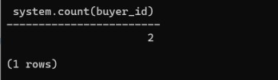

1. TO FIND ALL THE PURCHASES OF A PARTICULAR PRODUCT

select * from purchase_history where product_id = 4 allow filtering;

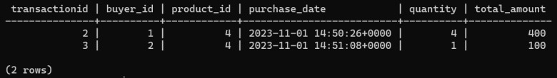

1. TO FIND TOTAL AMOUNT OBTAINED THROUGH SALES OF A PARTICULAR PRODUCT

select sum(total_amount) from purchase_history where product_id = 4 allow filtering;

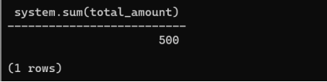

|  |  |
| --- | --- |
| 15    **Q4) Perform Social media analysis using cassandra** create keyspace social_media  ... with replication = {'class':'SimpleStrategy','replication_factor':1}; use social_media;    USERS TABLE :    create table social_media.users(  ... user_id int primary key,  ... username text,  ... email text,  ... registration_date timestamp  ... );    INSERTING INTO USERS :  insert into social_media.users(user_id,username,email,registration_date) ... values(1,'user1','user1@example.com',toTimestamp(now())); insert into social_media.users(user_id,username,email,registration_date) ... values(2,'user2','user2@example.com',toTimestamp(now())); insert into social_media.users(user_id,username,email,registration_date) ... values(3,'user3','user3@example.com',toTimestamp(now())); insert into social_media.users(user_id,username,email,registration_date) ... values(4,'user4','user4@example.com',toTimestamp(now())); insert into social_media.users(user_id,username,email,registration_date)  ... values(5,'user5','user5@example.com',toTimestamp(now()));  Section-A BDA Lab | JNTUH UCESTH |

USERS TABLE :

select * from users;

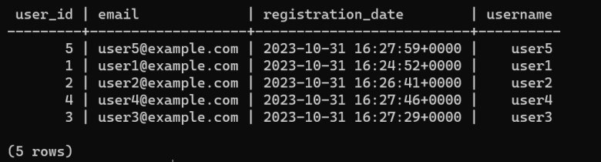

# Q5) Use R-project to carry out statistical analysis of big data Perform analytics on any standard data set dat <- read.csv(file =

"C:\\Users\\Dakshith\\Downloads\\Compressed\\Datasets\\inflammation-01.csv", header = FALSE) head(dat) output:

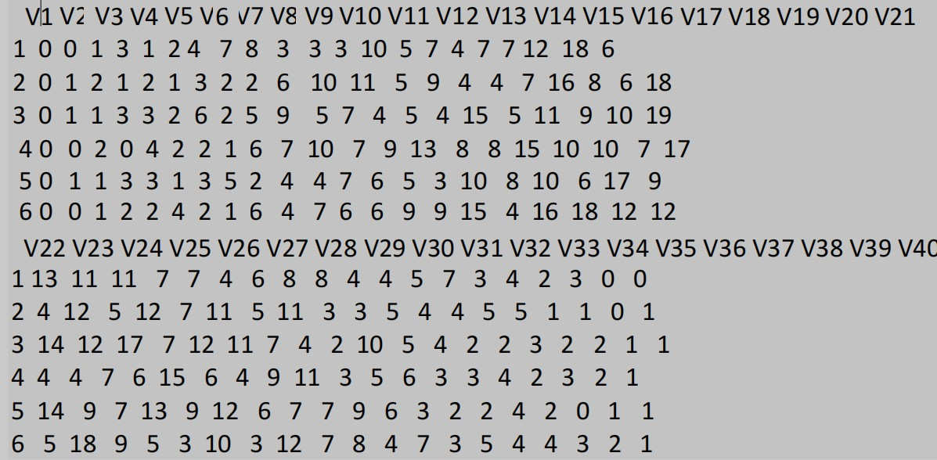

patient_1 <- dat[1, ]

# max inflammation for patient 1 max(patient_1)



max(dat[2, ])



min(dat[, 7])



mean(dat[, 7])



sd(dat[,7])



summary(dat[,1:4])

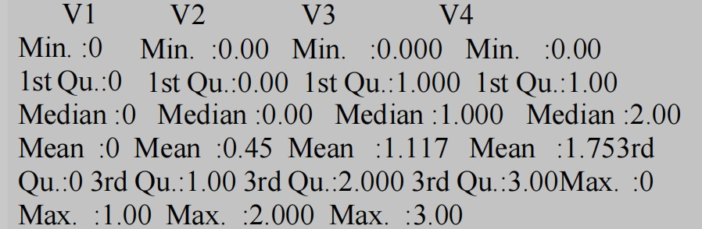

avg_day_inflammation<-apply(dat,2,mean) plot(avg_day_inflammation)

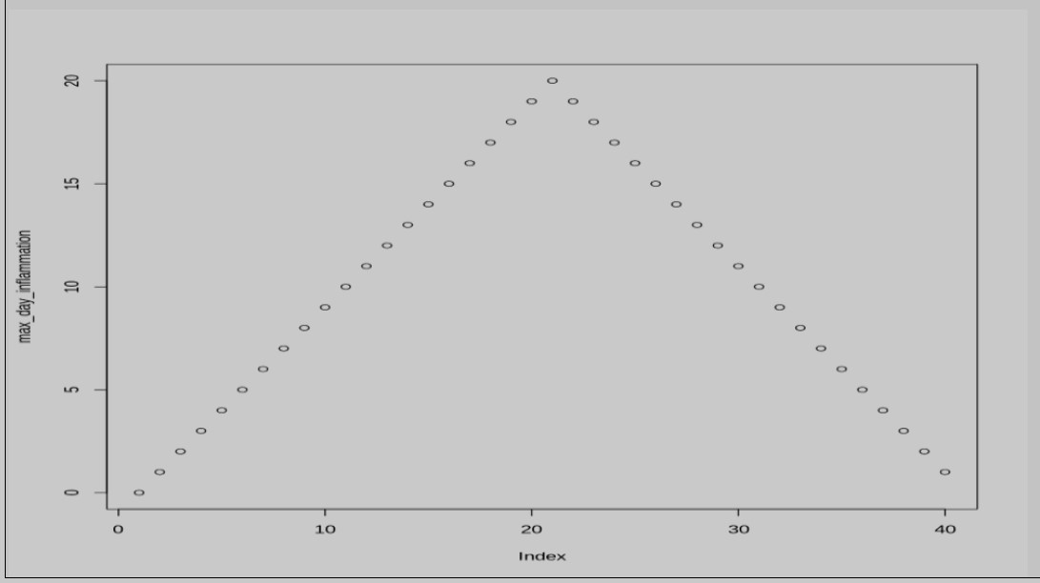

min_day_inflammation<-apply(dat,2,min) plot(min_day_inflammation)

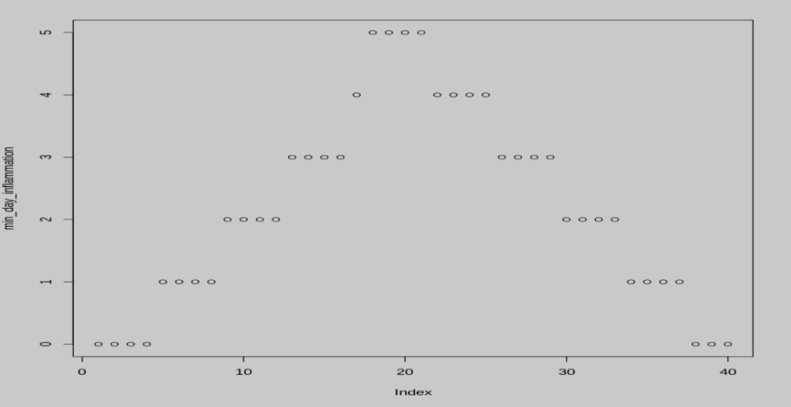

**Q6) Use R-Project for data visualization of social media data**

Bar Plot:

data(airquality) barplot(airquality$Ozone, main = 'Ozone Concenteration in air', xlab = 'ozone levels', horiz = TRUE)

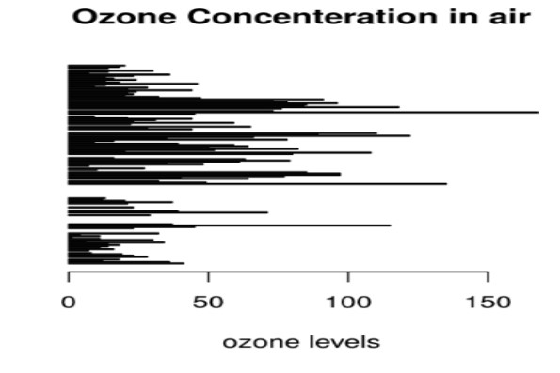

barplot(airquality$Ozone, main = 'Ozone Concenteration in air', xlab = 'ozone levels', col ='blue', horiz = FALSE)

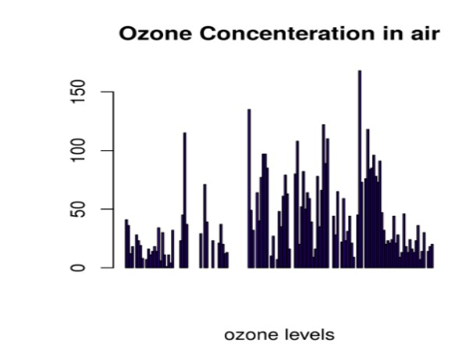

Histogram:

hist(airquality$Temp, main ="La Guardia Airport's Maximum Temperature(Daily)", xlab

="Temperature(Fahrenheit)", xlim = c(50, 125), col ="yellow", freq = TRUE)

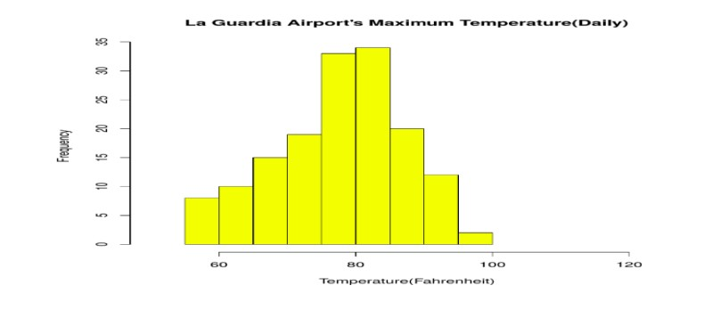

Box Plot:

boxplot(airquality$Wind, main = "Average wind speed at La Guardia Airport", xlab = "Miles per hour", ylab = "Wind", col = "orange", border = "brown", horizontal = TRUE, notch = TRUE)

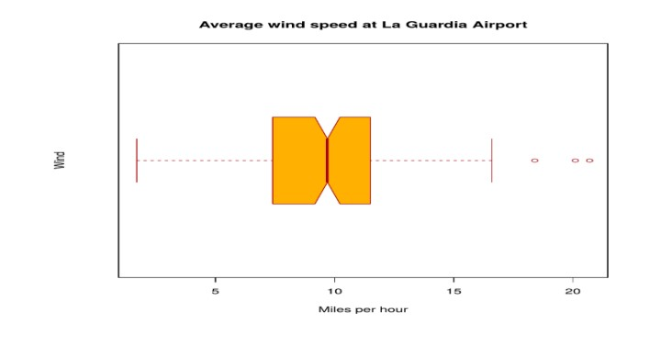

boxplot(airquality[, 0:4], main ='Box Plots for Air Quality Parameters')

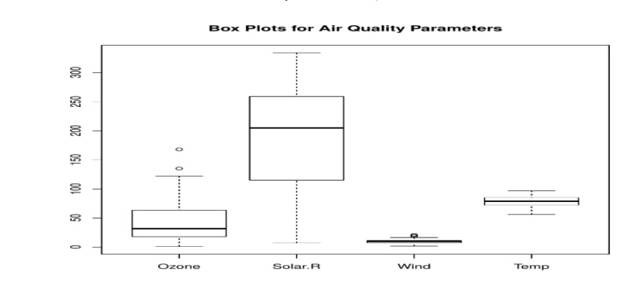

Scatter plot:

plot(airquality$Ozone, airquality$Month, main ="Scatterplot Example", xlab ="Ozone

Concentration in parts per billion", ylab =" Month of observation ", pch = 19)

